**PROPERTY ANALYSIS BI DEVELOPER- STANDARD SPRINT - PART 4- BUILD POWER BI DASHBOARD FROM EXISTING DW DATAWAREHOUSE**

**Task 20 : Using Existing KeysDW, Build Monthly Property financial report on PowerBI- rental income vs expense**

**Step 1: Select the PropertyKey,TotalRentalIncome and TotalExpenseAmount data to display the monthly property financial report in a table. Use a slicer to filter the EnglishMonthName. The scorecards are used to show the Total Rental Income and Total Expense Amount.**

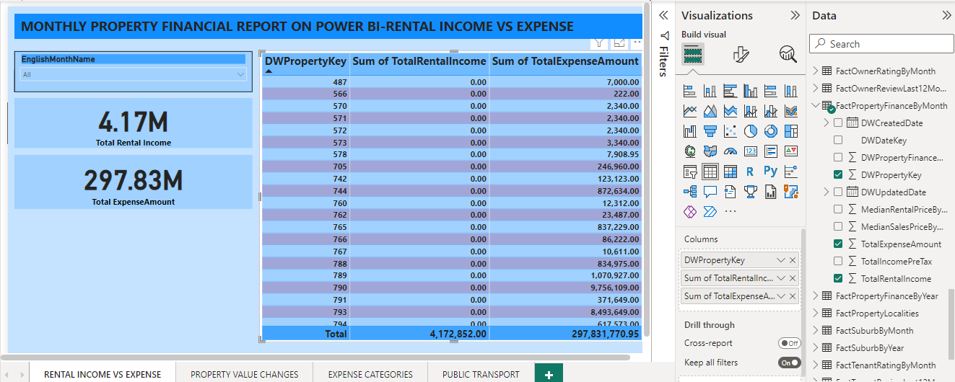

**SAMPLE OUTPUT :**

**On selecting the month(E.g. Oct) from the slicer, the sum of Rental Income and Sum of Expense Amount (monthly financial report) for the month is displayed in the table. The scorecards are used to display the Total Rental Income and Total Expense Amount**

**Task 21: Using Existing KeysDW, Build Line chart of Property Value Changes in the suburb of 1,5 and 10 years on DW**

**Step 1: Get Data->SQL Server->Write a direct SQL Query to display the property value changes of the suburb in 1,5 and 10 years**

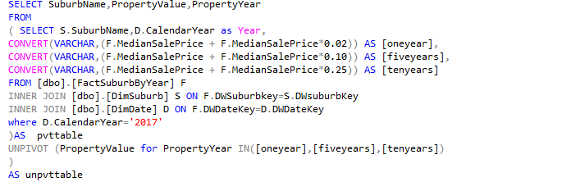

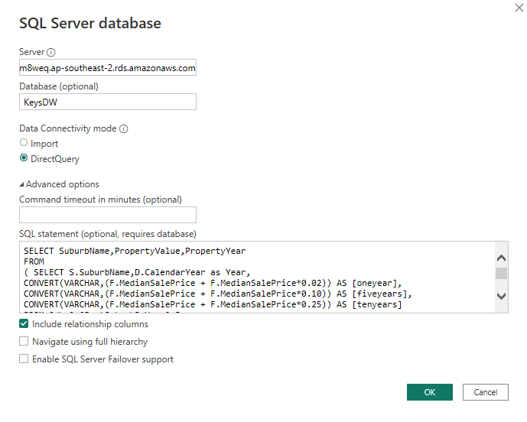

**Step 2 : Select the PropertyValue, PropertyYear and SuburbName from the Query created (Propertyvaluechanges) to create the Line Chart and use a slicer to filter the SuburbName.**

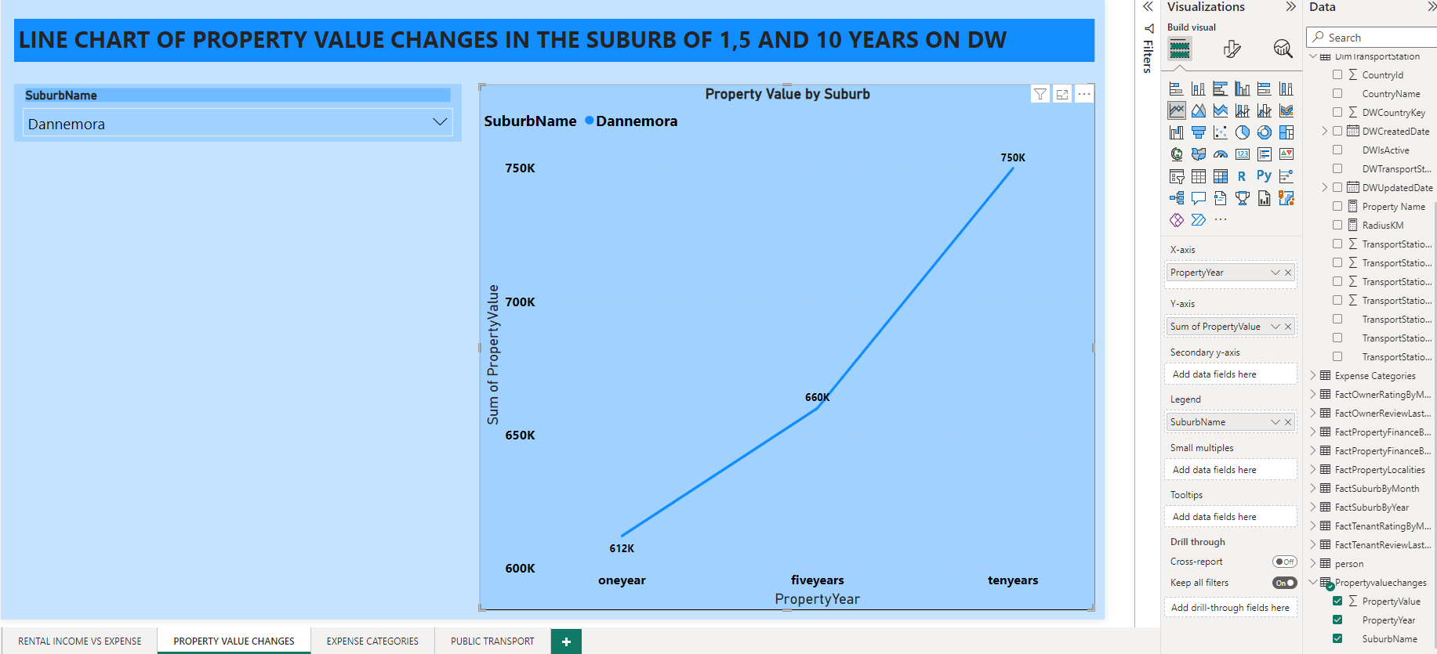

**SAMPLE OUTPUT:**

**On selecting the Suburb name from the slicer, the value of the property in the next 1 year, 5 years and 10 years is displayed in the Line chart.**

**Property Value of the Suburb Dannemora in 1 year.**

**Property Value of the Suburb Dannemora in the next 5 years.**

**Property Value of the suburb Dannemora in the next ten years.**

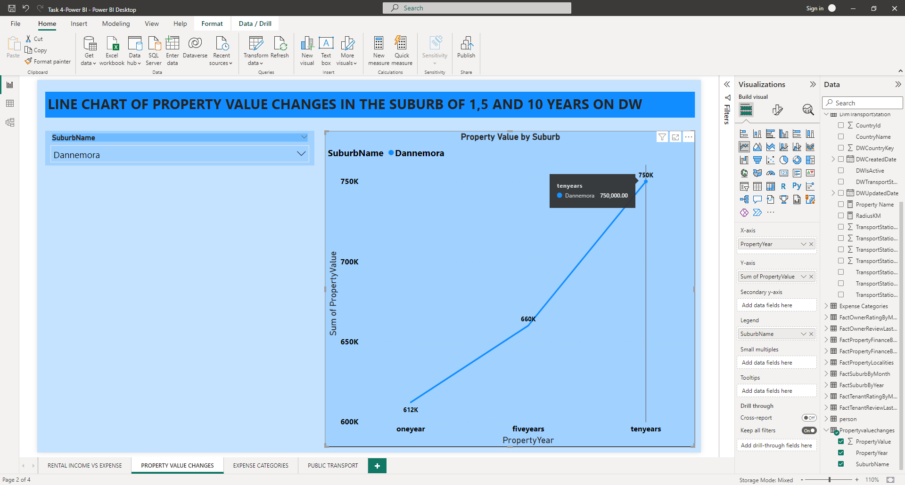

**Task 22: Using Existing KeysDW, Build Pie chart of all expenses categories on DW**

**Step 1: Get Data->SQL Server->Write a direct SQL Query to display the expense categories**

**Step 2: Select the Expense and Categories data to create Pie Chart**

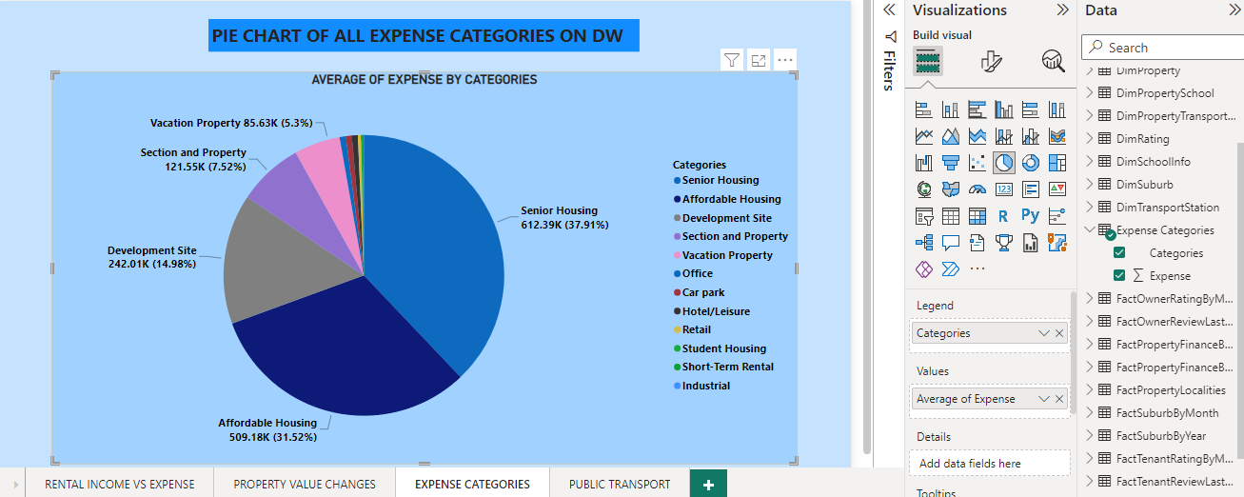

**SAMPLE OUTPUT:**

**Senior Housing category has the largest percentage(37.91%) of Expense in the Pie Chart**

**Task 24: Using Existing KeysDW, Build Custom map display Public transport within 1km radius of given input property**

**Step 1: Create a new measure Property Name under DimTransportStation using the below DAX formula.**



**Step 2: Create a new measure RadiusKm under DimTransportStation using the below DAX formula to calculate the distance between locations with latitude and longitude values.**

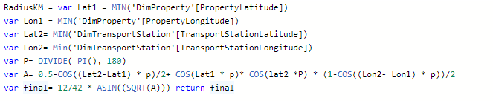

**Step 3: Use a Slicer to filter the PropertyName.**

**Step 4: Select PropertyName,TransportStationName, TransportStationMode, TransportStation Type and RadiusKM to create the Table.**

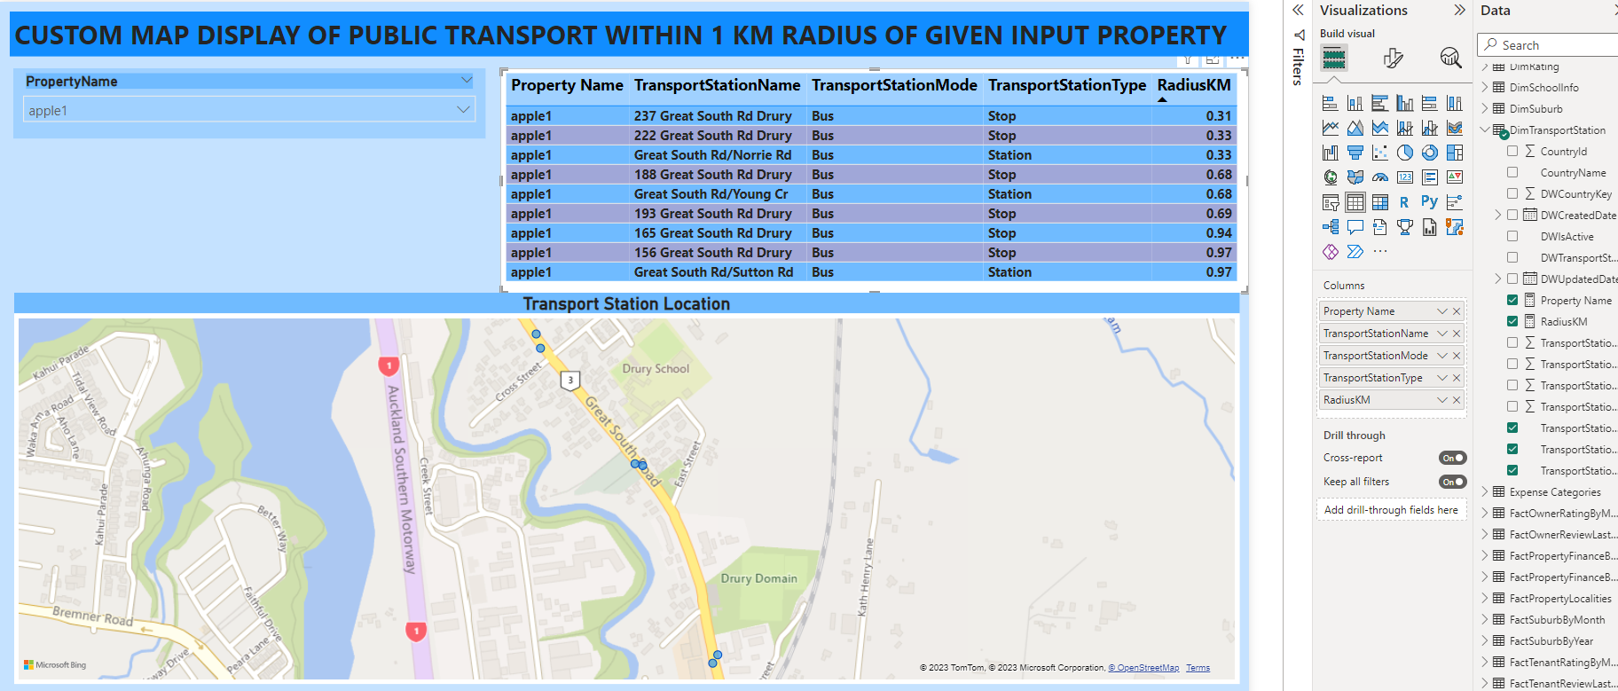

**Step 5: Select the TransportationLatitude ,TransportationLongitude and RadiusKM to create the Map**

**SAMPLE OUTPUT:**

* **Select the property name from the Slicer.**
* **The Transport Stations within 1km radius will be displayed in the table along with the Property Name, TranportStationName, TranportStationMode,TransportStationType and the distance as RadiusKM.**
* **The Latitude, Longitude values and the distance within 1 Km radius will be displayed in the map.**

**The Transport Stations within 1 Km radius for the property ‘apple1’**

